Project – 2

Social Media Data Integration and Analysis
- Login to the AWS Console
• Open your web browser and navigate to the AWS Management Console
• Log into the AWS Management Console with your account credentials
• Navigate to S3
• Click on Create bucket and add the bucket name as etl-twitter-blog
• Scroll down the screen and click on the Create bucket button

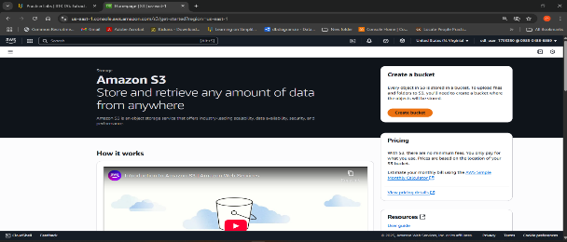
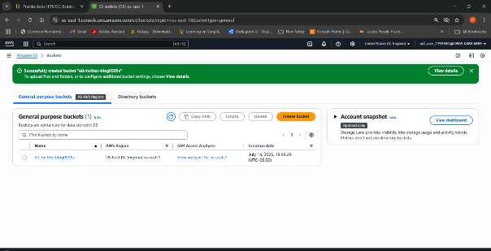
- Create two folders inside the etl-twitter-blog
• Click on etl-twitter-blog and Create folder. Add the folder name as etl-social-media for the first folder. Scroll down the screen and click on the Create folder button.
• Inside the folder, click Upload and click Add files. Select the sample_tweets file from your local system and click on Open.
• Scroll down and click Upload.
• Repeat the same step for blog-data and upload the sample_blogs dataset.

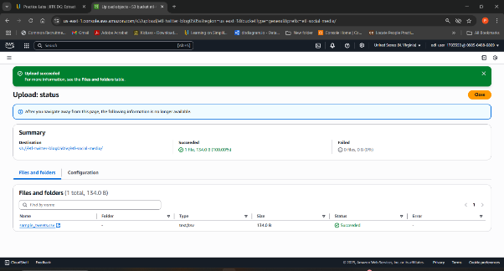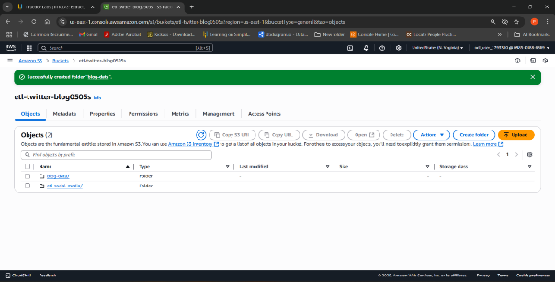
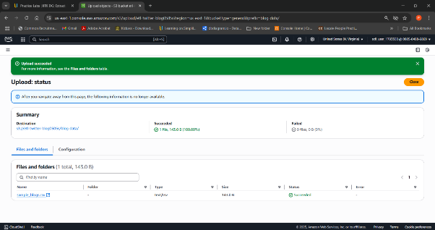

- Create a new bucket
• Create a new bucket named etl-cep-output, as you did above.

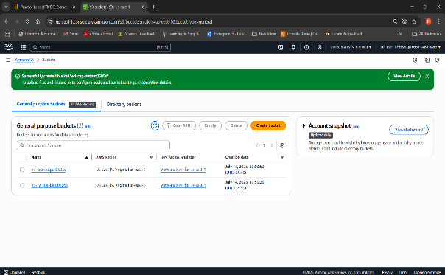
- Navigate to AWS Glue and create a new database In the AWS management console, search for AWS Glue and select it.
  - In the AWS Glue console, navigate to the Databases section
  - Click on Add database and provide the name as social_media_data. Scroll down and click on Create database.

  - 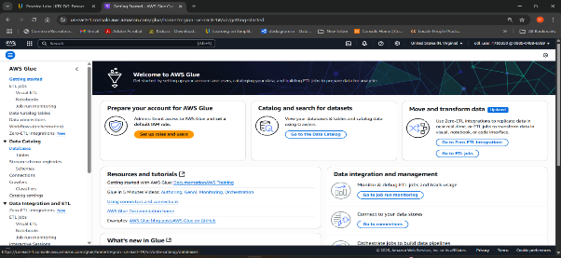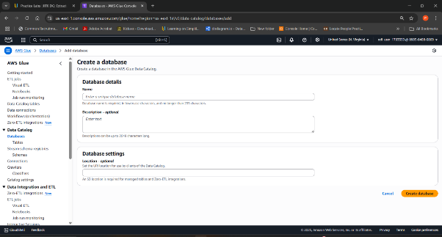
  - 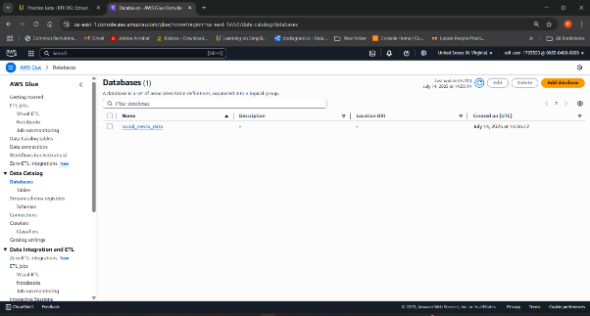

  - 5. Set up two classifiers to read transaction data and product data Navigate to the Data Catalog, click on Classifiers, and click Add Classifier.
  - Fill the first classifier details as given below, and click on Create

  - o Classifier name as twitter_data
  - o Classifier type and properties as CSV
  - o CSV Serde – optional as None
  - o Column delimiter as comma(,)
  - o Quote symbol as Double-quote(“)
  - o Column headings as Has headings 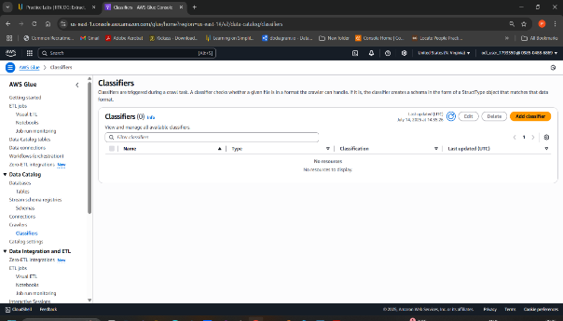
  - 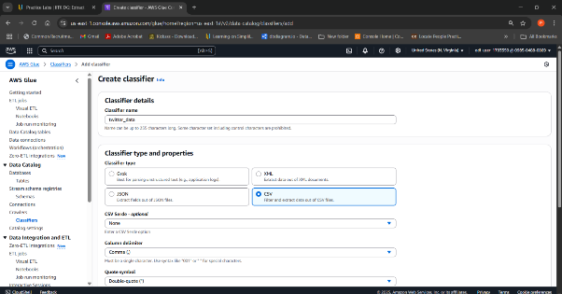

  - Fill in the second classifier details as given below, and click on Create

  - o Classifier name as blog_data
  - o Classifier type and properties as CSV
  - o CSV Serde – optional as None
  - o Column delimiter as comma(,)
  - o Quote symbol as Double-quote(“)
  - o Column headings as Has headings

  - 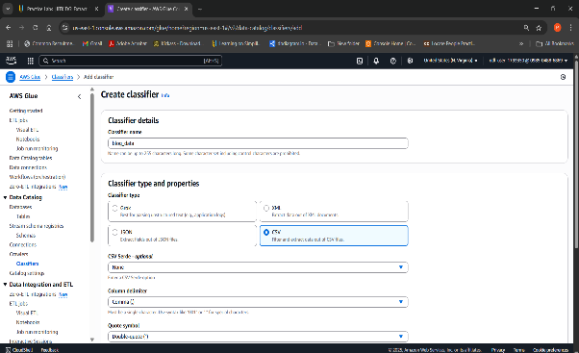
  - 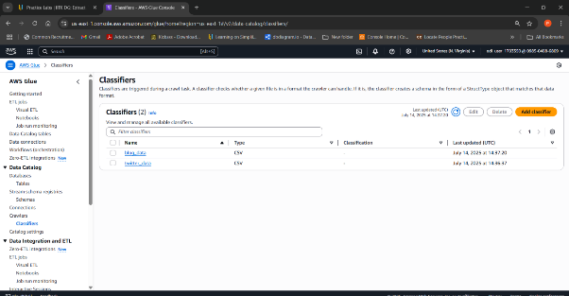

  - 6. Create an IAM role In the AWS management console, search for IAM service and
  - Navigate to Roles and click on Create role
  - Select AWS service as the Trusted entity type and Glue as the Use case and click Next
  - Select the AdministratorAccess policy. Scroll down and click on Next
Enter the name as glue-role. Scroll down and click on Create role.

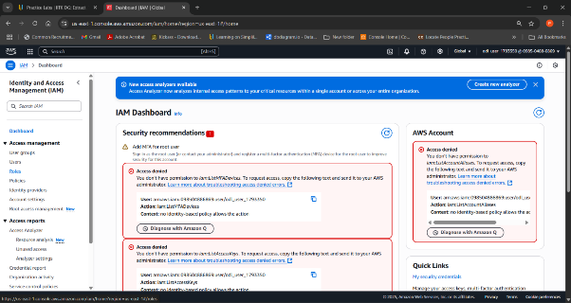
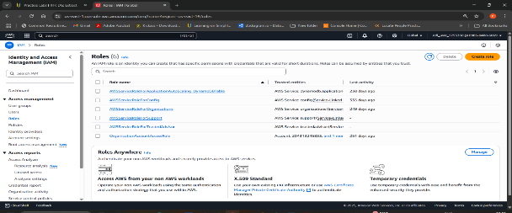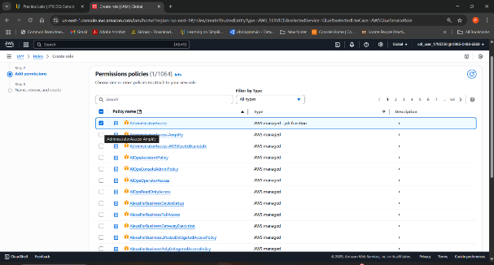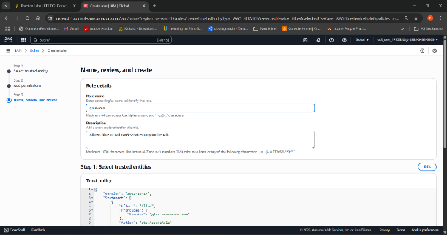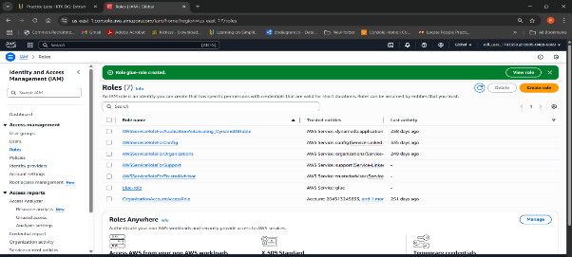

- Set up a Crawler Navigate to AWS Glue, click on Databases from the Data Catalog, and select social_media_data database
  - Click on Add tables using crawler
  - Enter the name as tweet-crawl and click on Next
  - Click on Add a data source
  - Click on Browse S3, click on etl-twitter-blog, select etl-social-media, and click on Choose
  - Click on Add an S3 data source
  - Choose classifier as twitter_data from the drop-down of custom classifiers – optional and click Next
  - Choose glue-role in the IAM role section and click Next
  - Choose Target database as social_media_data and click Next
  - Click on Create crawler
  - Click on Run crawler
  - 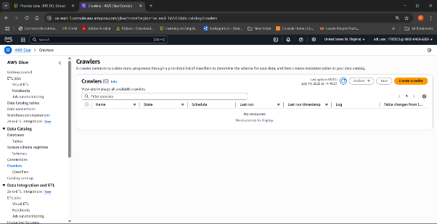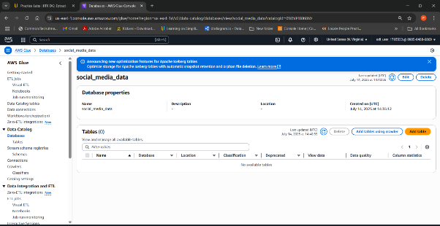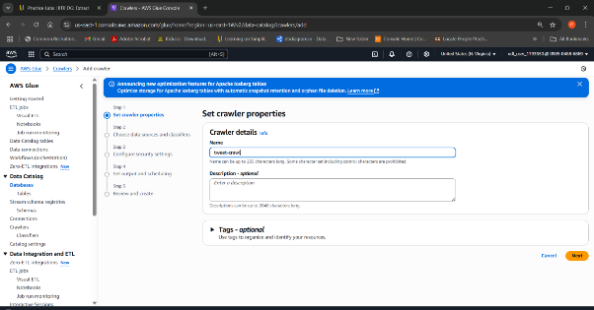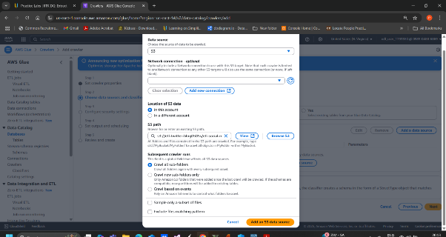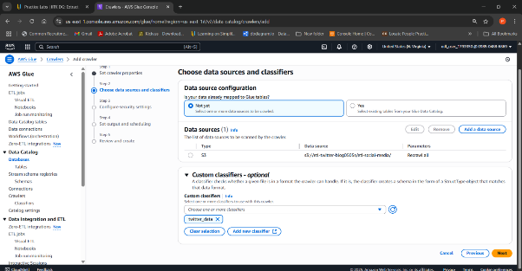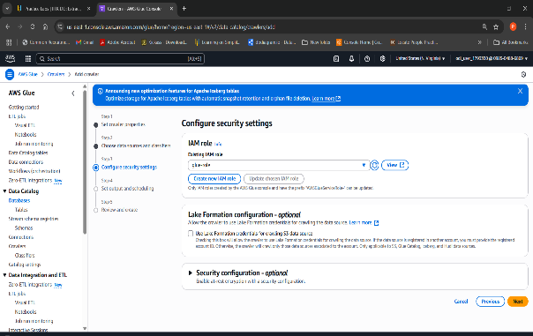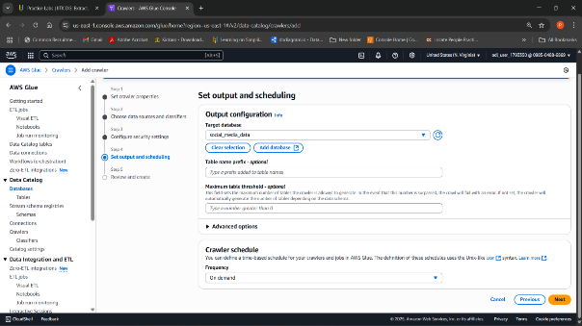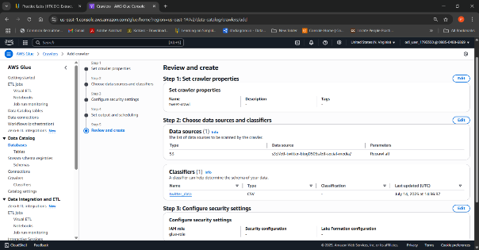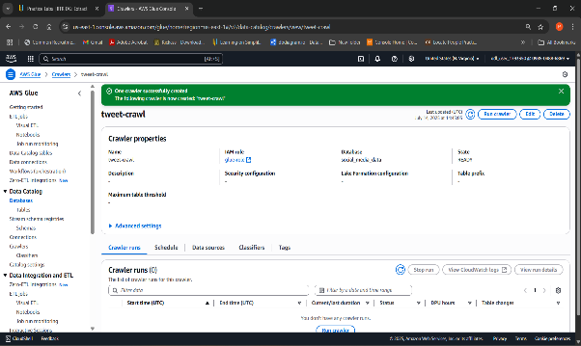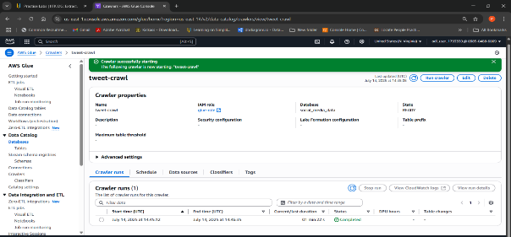

Note: Create a Crawler for Blog Data
- Repeat the above steps for the blog data, naming the crawler blog-crawler and using the blog-data folder and the classifier for blog data.

- 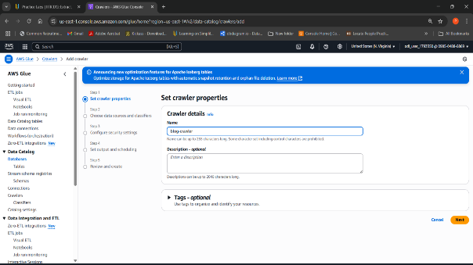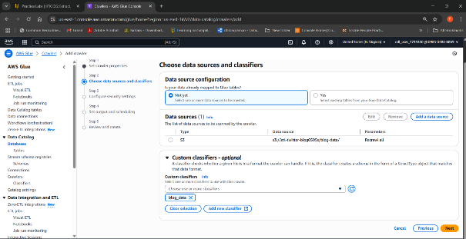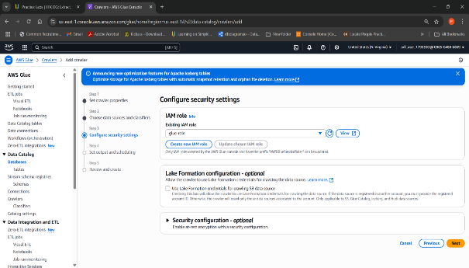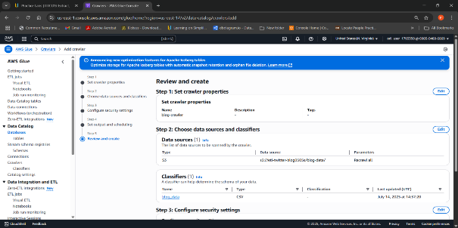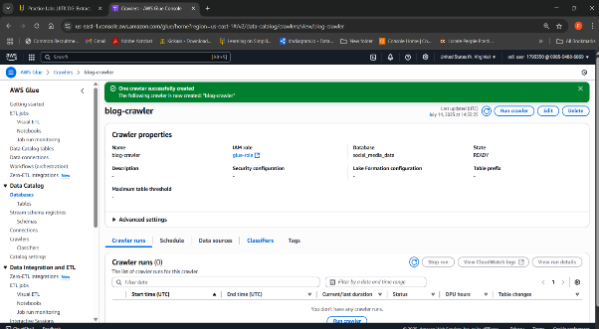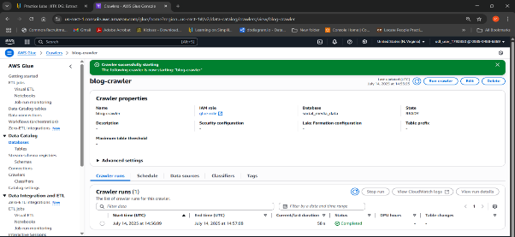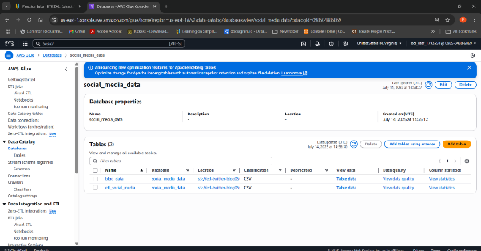

  - 8. Create an ETL job Navigate to AWS Glue, click on ETL jobs, and click on Visual ETL
  - In the Add nodes, double-click on AWS Glue Data Catalog
  - Select Join from the add nodes and link Join to both the AWS Glue Data Catalog
  - Click on the Join box and select Drop Fields from the Add nodes
  - Click on the Drop Fields box and select Regex Extractor from the Add nodes
  - Click on the Regex Extractor box and select Aggregate from the Add nodes
  - Click on the Aggregate box and select Amazon S3 from the Targets in Add nodes

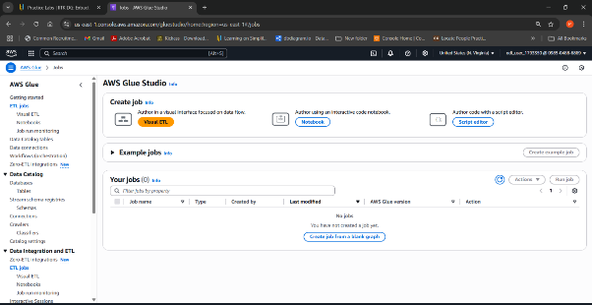
  - 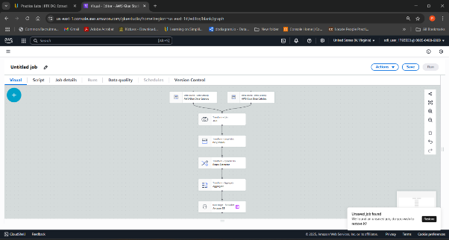

  - Click on the first AWS Glue Data Catalog box, select social_media_data in the Database dropdown, and select sample_tweets_csv under the Table dropdown
  - Click on the second AWS Glue Data Catalog box, select social_media_data in the Database dropdown, and select sample_blogs_csv under the Table dropdown
  - Select the Join box and add the AWS Glue Data Catalog in the node parents. Select Inner join in the Join type. In the Join conditions box, select the user id in both the AWS Glue Data Catalog boxes
  - Click on the Drop Fields box, and in the Drop Fields section, select the user id as it appears twice
  - We need to extract tweet text values as they have a # symbol. Click on Regex Extractor and fill in the following fields:
  - Now, let us create our summary report using Aggregate block.

  - Column to extract from as tweet text
  - Regular expression as #(\w+)
  - Extracted column as hashtags
  - Fill in the following fields:
  - Fields to group by as right_user id
  - Field to aggregate as tweet id and Aggregation function as count
  - Click on Aggregate a column, then in Field to aggregate as timestamp and Aggregation function as min Click on the Amazon S3 block, click on Browse S3, and select etl-cep-output
  - On the top left corner, click Untitled job and give the etl-cep-job. Now, click Save and click Run
  - Check progress in Runs
  - 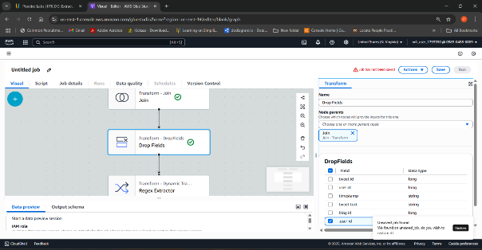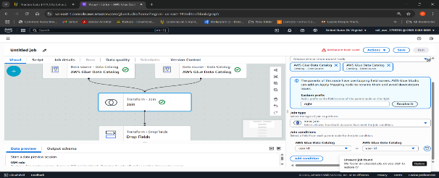
  - 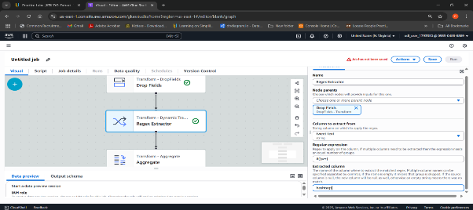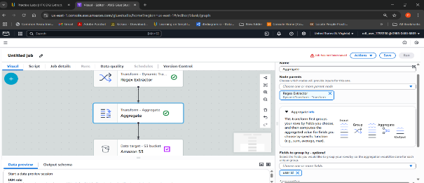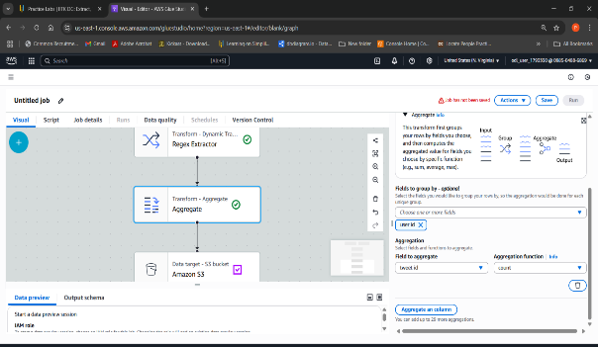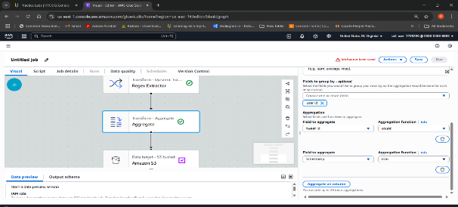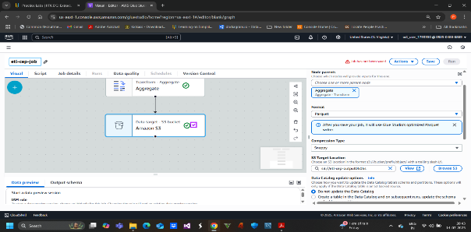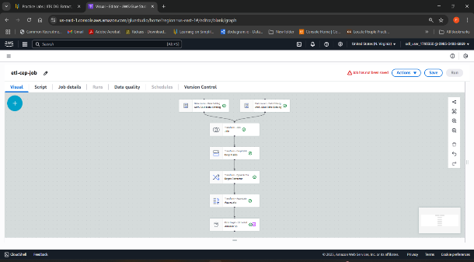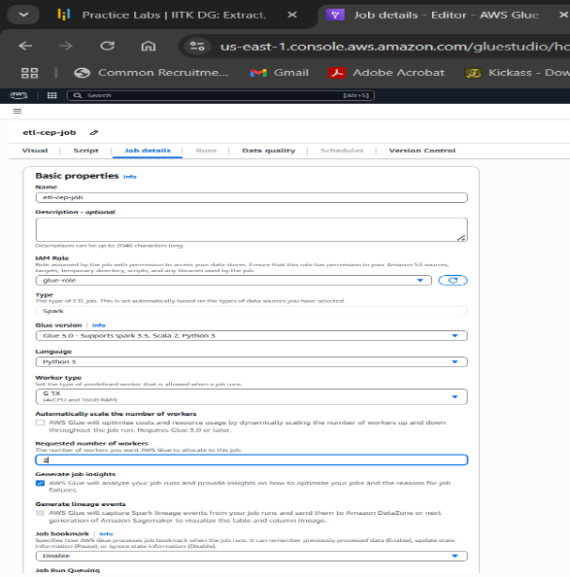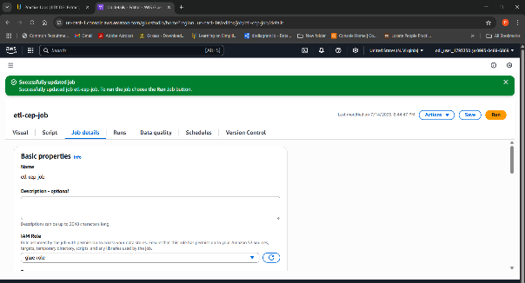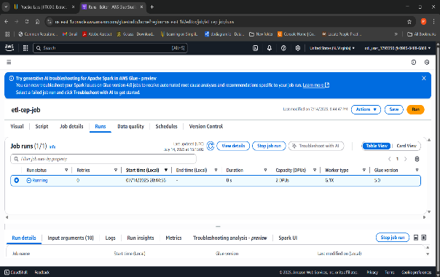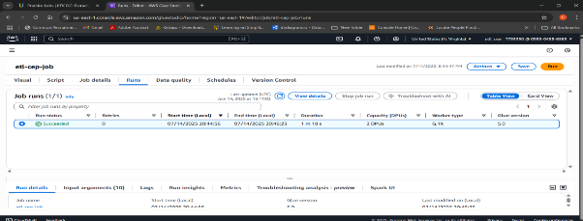

  - 9. Check the output and run the sql query Navigate to S3 bucket, click on etl-cep-output bucket to check the output
  - Click on run-1716301995938-part-r-00000

  - Navigate to Object actions and select Query with S3. Select
  - In the Output settings, select CSV format and click Run SQL query

